Sum a list but ignore any duplicates

DESCRIPTION:
Please write a function that sums a list, but ignores any duplicate items in the list.
For instance, for the list [3, 4, 3, 6] , the function should return 10.

SOLUTION:
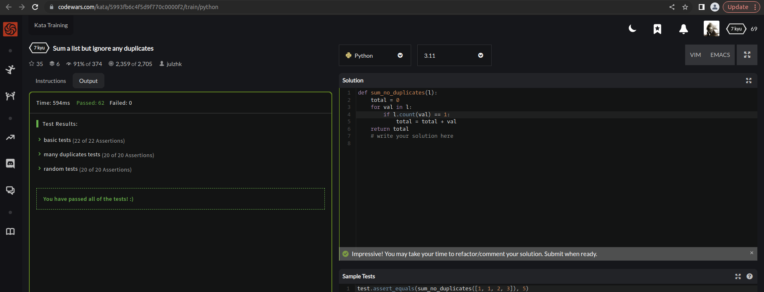

EXPLANATION:
This function takes a list of integers as input and returns the sum of all unique integers in the list. The function works by iterating over each value in the input list and checking if it appears only once. If so, the value is added to a running total. Finally, the total is returned.

